**BILKENT UNIVERSITY**

**ENGINEERING FACULTY**

**DEPARTMENT OF COMPUTER ENGINEERING**

**CS 299**

**SUMMER TRAINING  
REPORT**

**Mehmet Bora Kurucu**

**21703404**

**Performed at**

**logo2.png**

#### Stratek Strategic Technologies

**19.08.2019-20.09.2019**

Table of Contents

1 Introduction 3

2 Company Information 3

2.1 About the company 3

2.2 About your department 4

2.3 About the hardware and software systems 4

2.4 About your supervisor 4

3 Work Done 4

3.1 .Operation Design 5

3.2 Screen Design 6

3.3 Usage 7

3.4 Storage 8

3.5 ER Diagrams 9

3.6 The Integrated Development Environment 10

3.7 Coding the Law Project 11

3.8 Coding the Security Project 13

3.9 Applying Knowledge and Skills Learned at Bilkent 13

3.10 Solving Engineering Problems 14

3.11 Team Work 14

3.12 Multi-Disciplinary Work 14

3.13 Professional and Ethical Issues 14

3.14 Impact of Engineering Solutions 15

3.15 Locating Sources and Self-Learning 15

3.16 Knowledge about Contemporary Issues 15

3.17 Using New Tools and Technologies 15

4 Conclusions 16

5 References 16

6 Appendices 16

# Introduction

I interned at Stratek. This company prefers to work on multiple tasks, and change its focus based on the demands of the user. However, generally, they model and design software programs for different types of users. They design the programs for law intuitions, companies and other software developing companies.

Before choosing Stratek, I went to interview with multiple companies. One of them focuses on digital design and offered me to get involved with a Project which was about developing a chip using C#. However, I do not see myself working on hardware in the future, so I had to reject their kind offer. Another company that I interviewed with was focused on mobile game development. That seemed very interesting to me at first sight. However, I believe that mobile game development is possible with a considerable amount of research. So, I don't need to do my intern on that topic, as I am always able to learn it by myself.

So I continued my research, and those researches finally led me to the company Stratek. As I explained, I didn't want to work in a company that has only one focus, especially if that focus is on hardware. Stratek Works on a variety of topics, including projects for TBMM, TUBITAK, EU, etc. Also, they do modeling with programming which I find very important for a professional programmer. During my interview, my supervisor told me that I will be informed about the way that they design the projects. I will be taught to model and program a variety of projects on my own at the end of the interview. So, I saw how this company will contribute to my software developing skills, and decided to work with them.

At work, I got involved with 2 different projects. Their servers were on the constant attack by bots, so they needed a solution. I offered them to program a security system, which detects and bans the users who enter their passwords incorrect more than 3 times. They found it okay and started to work on it. I did the initial part of the project. I wrote a program which detects all the users who entered the passwords wrong. I also was able to detect those user's IP address and the number of times that they entered the password wrong. At that point, I left the project for them to complete to remaining parts, including connecting it the to the server and banning them. My second project was an about law file management system. They planned to start to project in October, but I offered to start and write some part of the code, which will make their job easier. To do this, I learned Html, database and C sharp all by myself, and managed to complete the initial project on time. I also learned a variety of UML and ER diagrams, to write the program more logically. It also helped in visualizing the problem, and I didn't spend too much effort on telling the program the others.

# 2 Company Information

## 2.1 About the company

Stratek Strategic Technologies founded in ODTU Teknkokent in 2002. It focuses on Software Development and Process Design. The company is especially developed in the field of public financial management. It is working with the Ministry of Finance and supported by World Bank refunds[1].

## 2.2 About your department

The company is not divided into departments formally. However, employees are divided according to their skills and depending on the projects. The technical team consists of software developers who do the modeling and programming. Also, the component works with 29 experts and 4 industry engineers, whose job is to design work institutions to determine the process [2].

## 2.3 About the hardware and software systems

As I explained previously, the company mostly focuses on software development. Hence, there is not any hardware system that needs to be considered here. Mostly C#, PHP, and HTML are used as programming languages. They prefer Visual Paradigm over other tools to create UML diagrams, but there are still some people who insist on using StarUML in the company.

## 2.4 About your supervisor

**Name**: Selin Bora

**Title:** Software Engineer & Business Analyst

**Education**:

– BS in Computer Engineering, Eastern Mediterranean University, 2010  
– MS in Software Management, Middle East Technical University, 2015

**Email:** [selin@stratek.com.tr](mailto:selin@stratek.com.tr)

# Work Done

As I explained in the introduction, I got involved with 2 projects. First of them is a ban system, which I will explain later. The other one is a law project, which is a case-management system for both the complainant and the defender. This project aims to make tracking cases and hiring lawyers easier for people. After setting up the general idea, the next step was planning

**3.1 Class Design**

Before beginning to anything at all, I needed to determine which classes should I have. The first two was easy to determine, admins and users. Also, certainly both admins and users need an id, username, and password for them to log in to the system. These may be okay for now, with these additions everyone would be able to login to the system. As explained, users should be able to track the cases that are related to them. Hence, there must be cases for a user to track them. Then, the cases class named “dosya” is created. The next step is to determine which attributes a case must have to create a logical system. A case should have an id(for programming purposes), a name, a lawyer, a place and a status. The reasons why the place and name are there are pretty obvious. Status is also needed because a user will always want to see what is the position of the case. Is it closed, is it ongoing, or is it canceled, etc. So a simple case class is determined which has attributes, id, name, lawyer, place, and status. A lawyer should not be only indicated by its name. So, it is not enough for an admin to add a case by only typing a name. A lawyer may be not available, or maybe the user wants to get in contact with the lawyer or learn some basic information about it. That brings the necessity of another class, “lawyers”. Since this is the only beginning of the project, basic information of the lawyer should be enough for now. Again writing the status of a case would not make sense as it does not with the lawyer, a status class should be created. So, the admin will be able to choose the status from all the current statuses instead of typing it. For the beginning, I only give the attributes, id, and status to the status class. So, the basic classes are set.

## .Operation Design

As explained, the classes are determined in the previous step. Now, the issue is determining which user is going to have access to which class. After they get their access, how are they going to use it. This kind of work would include hundreds of words, so I decided to show it visually. I asked my supervisor, and she offered me to use Use Case Diagram for it. Than I did a research on it, and when I completed it, I also found it good to get a help of a Use Case Diagram. First of all, I decided to make the Use Case Diagram for the class status. Firstly, I considered the most simple operations adding, deleting and editing. Also, those functions should only be accessed by the admin. So, the first use case diagram appeared. **Figure 3.0** illustrates a use case diagram for case.

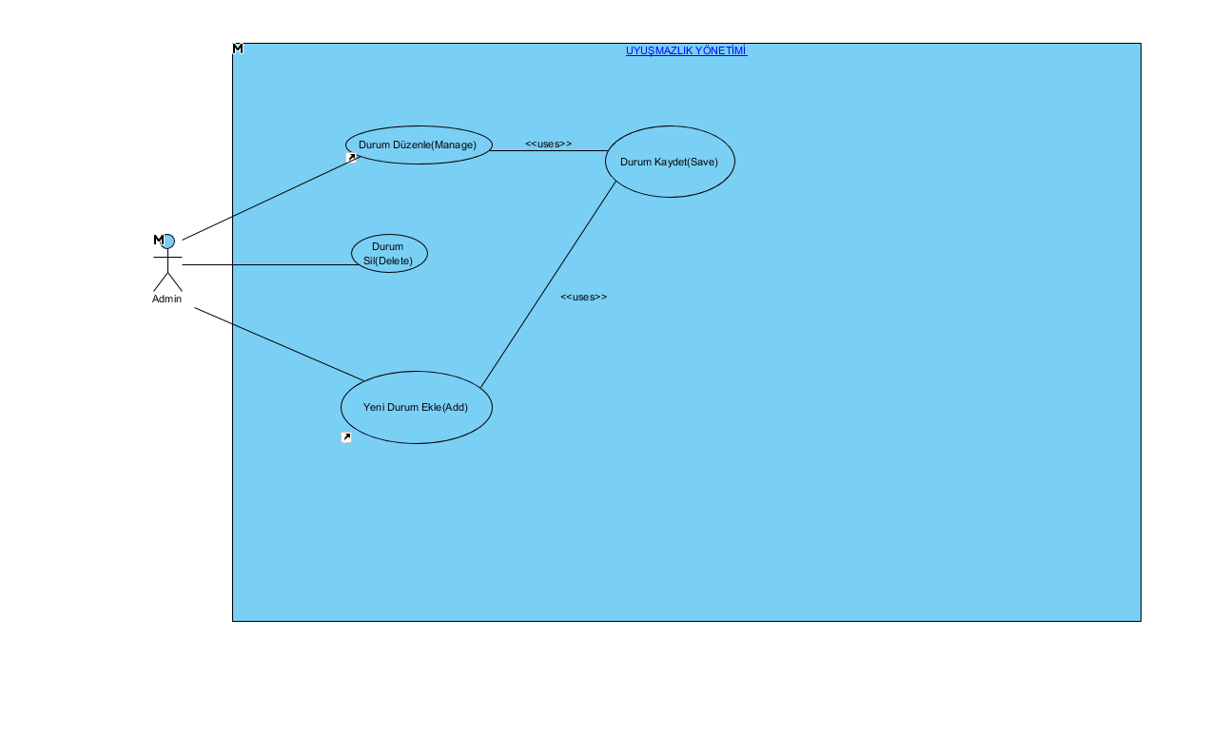

Figure 3.0: Use case diagram for case. User is able to add,edit,delete a case.

As I did for the class status, I only added the edit, delete and add functions to other classes as well, and gave access to the admin. So, similar visuals appeared. Now, the basic operations and it’s user type is determined. The other problem is to determine how and where are admins going to complete those operations. This brought the necessity of designing screens.

## Screen Design

Since only the operations edit, delete and add are considered, the simple screen would be enough. The only problem is how to make the admin to choose the right data to the operation. First, I thought about a screen where the admin searches by name, then delete it or edit it. I was planning to design the screens in that way. However, that seemed like too much time consuming for the admin, so I also decided to add a table, where all the data is displayed. Next, to the table, I added delete and edit options, so admin won’t have to search by name to those operations anymore, only select the correct row would be good enough. **Figure 3.1** illustrates user interface for status.

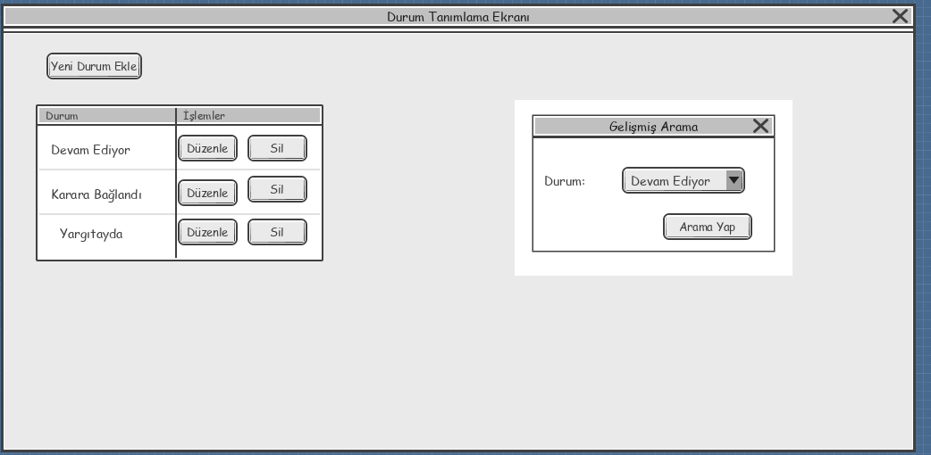

Figure 3.1:User interface for status. User is able to edit,delete and search a case.

So, the initial design seems completed for status. Admins will be able to delete the data by only clicking the button on the necessary row. However, edit and add operations are more complex. Since they are not that simple operations, another screen was necessary. The screen should display when edit or add buttons are selected. Hence, I designed another system. **Figure 3.2** illustrates the user interface to edit a status. **Figure 3.3** illustrates user interface to edit lawyers.

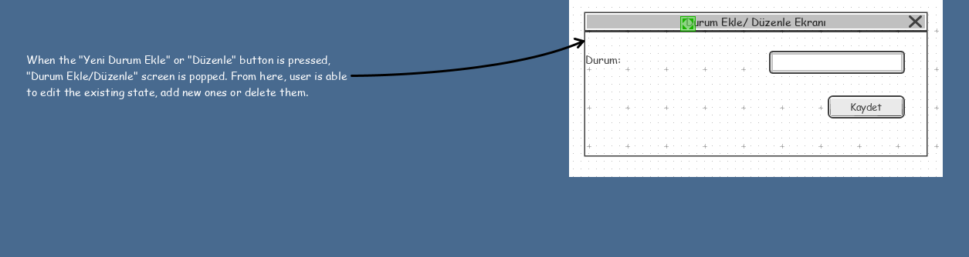

Figure 3.2: User interface to edit a status.

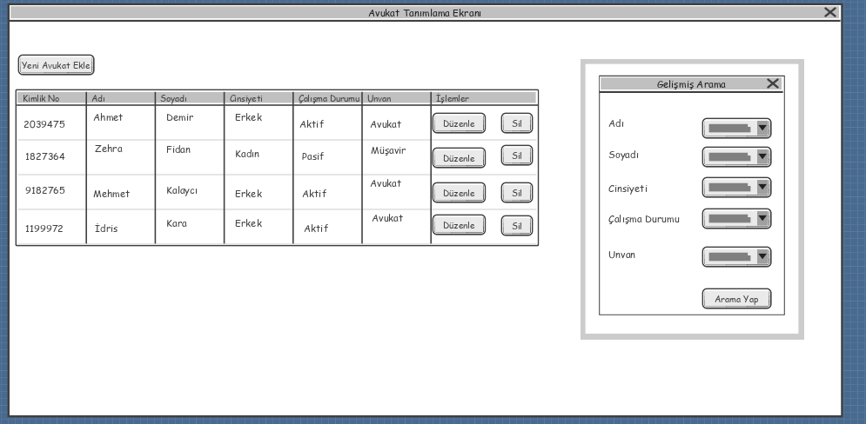

Figure 3.3: User interface to edit lawyers.User is able to edit,delete,and search for lawyers.

## Usage

Now, as the screens and use cases are added, the ways of using those functionalities should be described before starting the code. This can be done by changing the flow of events of the use cases. With that, every operation can be described step by step. **Figure 3.4** illustrates flow of events in status interface.

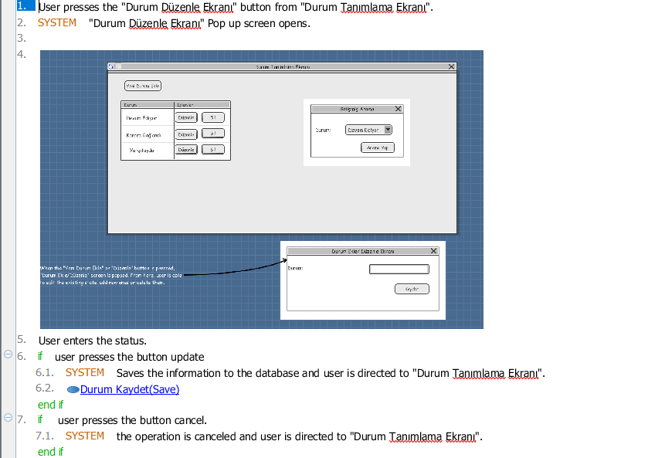

Figure 3.4: Flow of events in the status interface.

## Storage

Now, most of the operations are covered in detailed. The other problem is to determine which data those operations will work. In other words, the problem is to determine where to store all the information about cases, lawyers, statuses, admins and users. My first intention was to use text file’s as an artificial database as I did in my Cs102 project. However, there was a couple of problems with that idea. First of all, using text files as an artificial database is hard. I separated every data with a specific sign in my Cs102 project and separated every entry with a blank row. Doing operations with that kind of system was very hard. For instance, to get the name of a user, I skipped that three those specific sign and took the word between the other two signs. This ended up, ages becoming expressions like “|19”,”37, “,”21 ! “, because of the problems in my indexing. Also since I am a third-year now, I thought it would be too amateurish. Hence, I decided to use a real database system. That seemed hard to me since I haven’t taken any database course yet. After days of researching, and like a dozen failed attempts, I finally came across with MySql. That was harder than it seems since my only source was some Youtube tutorials and forum posts. I learned the syntax of MySql in a couple of days. Before moving on to the actual database that I need, I created a test database and did some code practice here. Also, I downloaded some of the prepared databases for MySql[2]. After all this work, my test database became like in **Figure 3.5.**

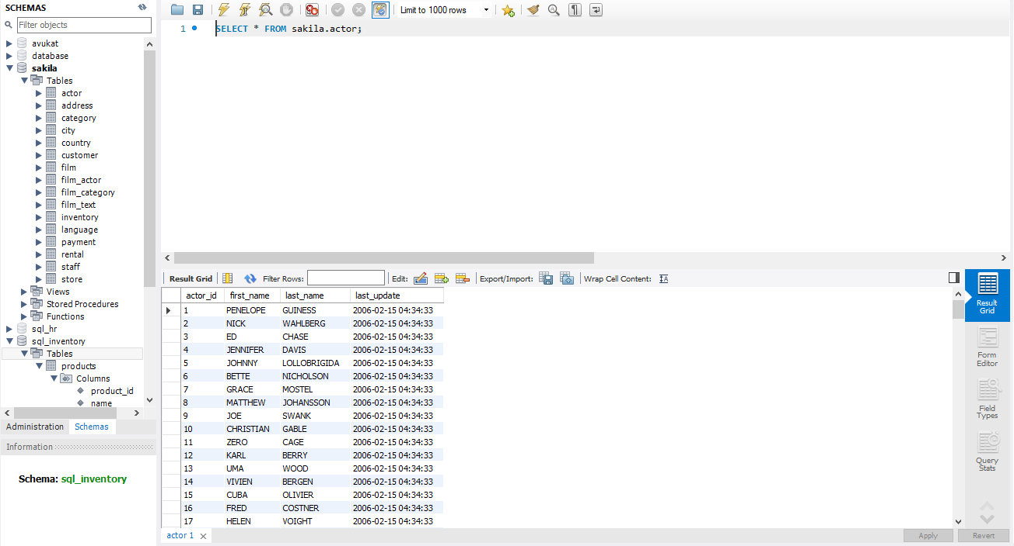

Figure 3.5: The database I created to study database.

I tried a lot of different commands and codes. I constantly wrote and deleted them. Since it would be very hard for me to put all of them here one by one, I copied them to a text file, and entered a blank space to indicate different trials. After certain amount of practice,I moved on to the actual database. The classes I mentioned at the beginning were transformed into tables of database, and those attributes become the attributes of the tables. So here is the table for the admin database in **Figure 3.6.**

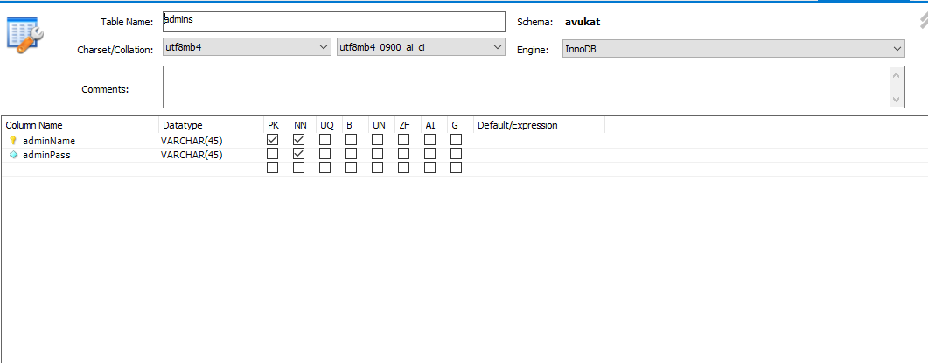

Figure 3.6: The database for admins.

## ER Diagrams

Now the database, the screens, and the operations are ready. I was about to start the code at that point. However, my supervisor informed me about ER diagrams, which visually describes the relationship between the entities of the database. Hence, I designed it to make the coding process easier. **Figure 3.7** illustrates the ER diagram. As can be understood from this diagram, one user may have more than one files. For instance, a person may have more than one specific guilt to be investigated, which leads to multiple case files. Also, one lawyer may have more than one file to work on, but every file needs to only have one lawyer. Also, each file must have only one status, since they can’t be “ongoing” and “closed” at the same time. However, a single status may be used for more than one case since there can be more than one case which is “closed”.

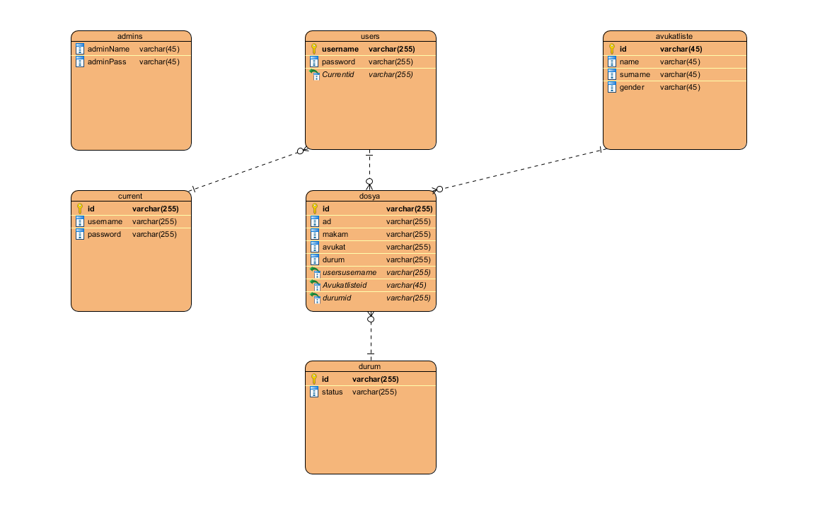

Figure 3.7: ER diagram. Boxes stands as classes, and the class properties are placed in the boxes. The relationship between classes illustrated with arrows.

## The Integrated Development Environment

First, I intended to write the code in Codeblocks in C++. However, I realized that it was very hard to connect the MySql Database the .cpp files that Codeblocks creates. Then I continued my research. After a single day, I come across with an IDE that I have never heard before: Visual Studio. The information I found online said that this IDE is one of the most common ways of using a MySql. However, since it is a new IDE for me, I encountered dozens of problems. The first problem was the variety of projects that Visual Studio offers, and I didn’t which type of projects work with MySql. Also, some type of projects didn’t support the Library System, which essential for getting user input. I wrote a sample code, which is a simple calculator. The calculator was the example I choose because it requires getting user inputs correctly, and again showing the result in the database. The code itself is a basic code, which adds the numbers user-entered if user presses calculate, etc. And here is one of the errors that I took in various project types in **Figure 3.8**.

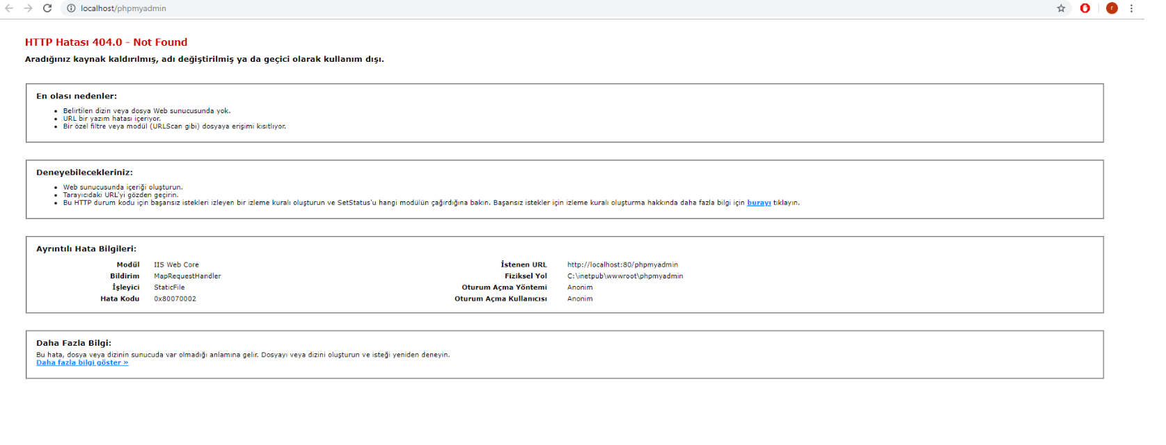

Figure 3.8: 404 HTTP error en countered in the project design.

After all of those trials, I finally got a project that can work the calculator correctly. Apparently, the correct project type is ASP.NET Web Application which uses C# as the programming language. Actually, writing in C# was very easy despite the fact that I didn’t know it.

## Coding the Law Project

As one can see easily in the screen designs, most of the screens work on a very similar principle. They require a listing of the required data, and addition of edit and delete buttons to that list. Also, there should be another button to add new information. So, I will cover the operation on lawyer here to not fill the report with code. However, with only the case, other parts can easily be understood, as case one is the most complex one.

First, I created a WebForm named “dosya” to handle all operations related to case. This result in the creation of “dosya.aspx”,”dosya.aspx.cs”,”dosya.aspx.designer.cs” files. The first step was to design the screen, which is done via dosya.aspx file.

First, I created a table in dosya.aspx file which showed the data related with the case. The table took the information from the database table and showed the values under proper headlines. Here is the table in **Figure 3.9.**

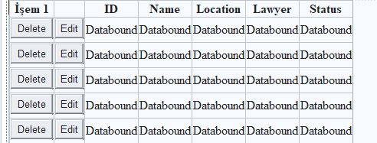

Figure 3.9:GridTable for files. Shows ıd,name,lawyer,status information of the file.

This simplest operation is delete.The idea is simple, I open the connection, I get the id of the row that is desired to be deleted, than I delete it, and update the table.The second easiest method is the add method. However, as can be seen in the screen, it requires a new screen where the user should enter the related information. Hence I created another WebForm named dosyaekle, which brought “dosyaekle.aspx”,”dosyaekle.aspx.cs”,”dosyaekle.aspx.cs” files with it. This part is very simple,user just enters the values here as in **Figure 3.10**.

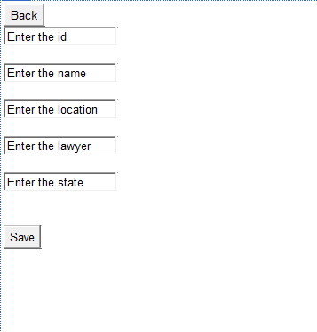

Figure 3.10: User interface to add a case. Use enters the required information, then saves it.

The most complex method here is the edit method.When the edit buton is clicked, girdview becomes invisible, and other textboxes become visible,after user enters each of them, the information is updated.

All the information is taken from textboxes, than the operation is done.

Furthermore, there is a login page, which redirects user according to information entered. If the combination belongs to the users table it redirects it to users,if it belongs to admins, it redirects to admins. In the users page,all the cases carrying the name of the user is listed, the code is not that different from the previous codes. It again uses a gridview table,but only displays the data that has the specific names. So,I found it illogical to include to code here. Also, I use a signup page, where users enter the requested information, and confirms it by mail. Here is the shortened code of confirming the mail. Than I compare the entered code and the sent code,add the user database if they match.

Note that these are all very shortened versions of the codes. Writing the codes took weeks and the total size of the codes are over 5000 rows. Here is the list of all classes I used in the **Figure 3.11.**

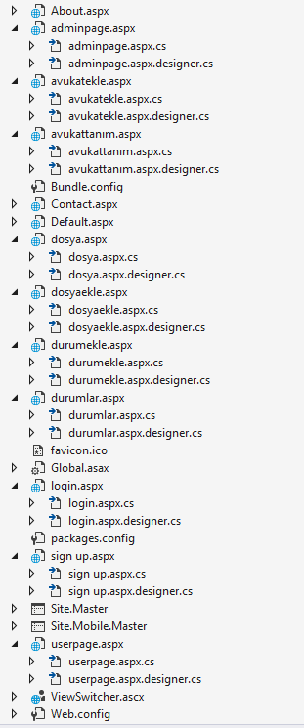

Figure 3.11: All of the classes that is created in the project.

## Coding the Security Project

As explained previously, the other project that I got involved was the security project. My aim in this project is to detect some information about the users who entered their password wrong. I just read through the eventlog, and add the information of users who entered the password wrong.

Performance and Outcomes

## Applying Knowledge and Skills Learned at Bilkent

C# is very similar with C++. So, Cs201 and Cs202 really helped me with the syntax. Also all the information about efficiency that is taught to in Cs202 is a factor for me to give up using txt file and move onto a real database. The algorithms and problem solving abilities that I gained Cs101 and Cs102 helped me in developing algorithms. I didn’t have hard time writing the code after I learned the syntax. The most important skill I gained in Bilkent is researching. I researched and learned everything by myself.I used my knowledge from Cs102 to design the screens. In actionlisteners, I used similar methods that I used in cs102 project. Cs201 and Cs202 homework helped me to organize the task into separate classes. I didn’t know about database before the summer, and I learned it thanks to the research skills I gained in Bilkent.

## Solving Engineering Problems

There are a lot of problems that I faced while writing the code. There were many bugs, some of the project types didn’t support the libraries I needed. The only solution was spending time on it, correcting and trying it again until it starts working in the desired way. I just entered the problem Google and searched it, and continued to gain knowledge about the problem until I find a way to fix it. To solve the problems, I mostly used the website stack overflow, which includes various solutions to popular bugs, syntax errors, etc. I also got help from other programmers around. My supervisor initially told me about the general way of doing the project, selected good tutorials from various options. I mostly learned database,php and other computer engineering knowledge from these tutorials. Those tutorials mostly from khan academy,geeksforgeeks,courseera which are all online websites for computer science.

## Team Work

I studied with various employees during my internship. I believe I developed my skills in the professional area. Now I am able to stay more calm, and can handle more problems than before. Especially during the times that I had no idea, their 1 hour of help saved me more than one day since learning by researching is beneficial but also takes too much time. However, most importantly I learned nothing to expect from other people in professional work. Everyone’s time is valuable for himself/herself, so no one is actually willing to help others without any benefit. Hence, I learned that I should be able to learn everything by myself, with expecting least amount of help from others. So, I mostly gained help due to formality, and had to deal with most problems with myself.

## Multi-Disciplinary Work

I was trying to publish a website during all of these work. I wanted to create a website for the law project, so I created a template one : borakurucu.cf. However, it does not have anything due to the problems in the codes, but the website still exists. Actually the website is ready, but the website provider with php code, but since I am not very experienced in php, the main screen can not be opened yet due to problems in my code. Maybe, one day I will change the website to post the law project I created if the company allows. I was also trying to learn machine learning and artificial intelligence from online courses.

## Professional and Ethical Issues

I actually planned to create a rating system for the lawyers. Users would be able to rate their experiences with the lawyer. However, I thought that it may be unfair for the new lawyers that added to the system. They would have to compete a lot, I found it unethical and didn’t create the system. To decide this, I used my knowledge from another course in Bilkent: Ge301. This is course is based on analyzing ethical issues in technological revolutions. After all I decided to remove rating system for lawyers. However, a commenting system like in Bilkent may be used. Although it is unethical, people need to have right to gain knowledge about lawyers, so a rating system may not be that wrong. Gaining knowledge may be enough to ignore some ethical issues, depending on individual perspective.

## Impact of Engineering Solutions

The solutions are the factors that made that project working. Also it had an impact on me. I saw that every problem has a solution if one has enough time to spend it. Also, I believe that especially a computer scientist should have the ability to solve them problems with only his/her individual work. Since my primary is to make the project work, my solution is to use code as simple as possible. This means avoiding data structures like heaps,avl trees, etc. Since those may be more useful at some points due to their lower order of complexity in operations like retrieval, insertion, etc, one may choose them. However, I always find useful to first always relying on hash tables rather than other structures, since they are simpler. Also the input sizes were relatively smaller, so time complexity was not a problem.

## Locating Sources and Self-Learning

I believe that a programmer should not rely on teamwork, at all. All people have their own valuable time, and willing to use it for their own good. Hence, a programmer should not expect any help from other people. Although, I tried to get help from other people, I was aware that I had to the most part of the learning by-myself. Hence, I mostly stayed quiet, did not ask for help unless it was very simple syntax related issue.Hence,I mostly got help from various websites and forum posts. Especially stackoverflow and geeksforgeeks was very useful. I also used youtube and watched a lot of database tutorials from that platform. When I couldn’t find any help in those sources, I tried to learn it by myself, by changing the code and trying until I get the result that I wanted.

## Knowledge about Contemporary Issues

I stopped using text files as arbitrary database and learned about the actual database. I learned what is a host, what is a root and more. I believe this is one of the most essential skills of a programmer who needs to store data somewhere. Now, I am able to write project using database systems. Now using my knowledge from cs102 project, cs201 and 202 knowledge and database, I am able to create basic games. I also gained a lot of practice in various programming languages. I realized differences between languages and which to choose where. Html and php are useful in website design, I do not prefer java due to absence of pointers. Perl is very useful if one wants to benefit from both dynamic and static scoping.

## Using New Tools and Technologies

I didn’t know about modeling,UML diagrams,ER diagrams,Usecase Diagrams,C#,Database,php,html and more. In this intern I gained a considerable knowledge about all of them.Actaully I learned how to make a project. First I learned how to design user interfaces. I learned that I should not right jump into coding. After designing the interfaces, I learned that I should do flow of events, which explains how user screens are related. After that I learned that I should design ER diagrams, which shows how the database is structured. Thanks to all, I did not struggle that much in the coding part since the ideas were previously settled. In the coding part, I learned php, html, database which are all new to me.

# 4 Conclusions

# In the internship, I participated in two different projects. First of them is a law project, which is about a system where users can see cases about them and manage them. Cases have lawyers, statutes, and other attributes. To do that, I added the admin class, who can add cases, remove cases, add lawyers, statuses and more. I used visual studio, learned about MySql Database, wrote code in PHP and C#. Before beginning the code itself, I learned modeling to make the process of coding easier. I learned about UML diagrams, Usecase Diagrams, and ER Diagrams. Thanks to those models, writing the code become easier. Also, I wrote code which detects the IP address and number of attempts of users who enter their passwords incorrectly. I used the event viewer and event view reader for that project. That project has a lot of potential like stopping and banning the attackers since I can get their Ip address correctly.

# 5 References

[1]”Hakkımızda”.

http://www.stratek.com.tr/hakkimizda.aspx.[Accessed: Sep 20,2019].

[1]”Ekibimiz”.

http://www.stratek.com.tr/ekip.aspx.[Accessed: Sep 22,2019].

# 6 Appendices

The code would take another 30 pages if I posted it here. The codes are available in:

<https://github.com/BoraKurucu/Law>

<https://github.com/BoraKurucu/Security>

**Self-Checklist for Your Report**

*Please check the items here before submitting your report. This signed checklist should be the final page of your report.*

* Did you provide detailed information about the work you did?
* Is supervisor information included?
* Did you use the Report Template to prepare your report, so that it has a cover page, the 8 major sections and 13 subsections specified in the Table of Contents, and uses the required section names?
* Did you follow the style guidelines?
* Does you report look professionally written?
* Does your report include all necessary References, and proper citations to them in the body?
* Did you remove all explanations from the Report Template, which are marked with yellow color? Did you modify all text marked with green according to your case?

Signature: _______________________